Hit & Run Meter

Design
- Should be visually incorporated into the HUD radar
- The overall size of the radar should not increase
- Meter should be identifiable as a distinct item on the Radar (one proposal is a thin bar that circles the radar)
- Meter and Radar will be on the screen at all times
- Meter should be subtle yet easy to understand
- Meter should be analogue not unit based (i.e. not “bars” of damage)
- Meter should have a visual unique colour (yellow?) up to 75% full and then a visually different colour (red?) from 75% to 100% full
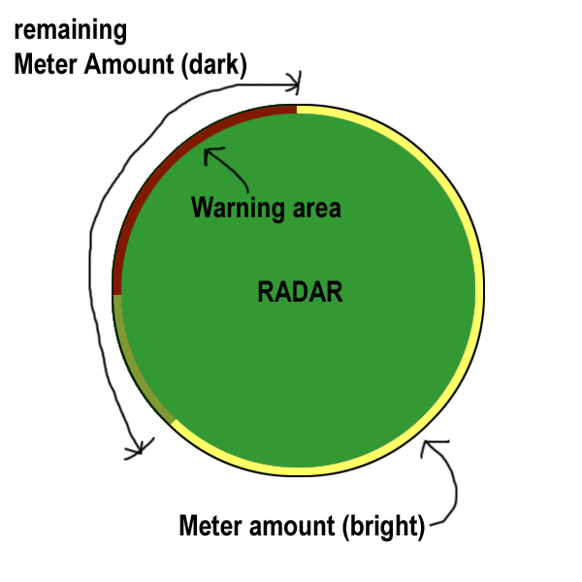

Function
- The meter will increase a unique amount when the player
  - Hits/kicks a pedestrian
  - Breaks a cola-prop
  - Destroys a traffic vehicle
  - Hits a moveable/breakable
  - Other TBD
- The meter will decrease
  - Over a set rate over time
  - Over a set rate over time when in interiors
  - When the player switches skins
  - When the player switches vehicles
- When the meter reaches 75%-100% full the meter will…
  - Emit a unique warning sound
  - Emit a unique warning sound
- When the meter reaches 100%
  - Hit & Run HUD message will appear on the screen
  - Emit a unique hit & run sound (while meter is between 75%-100% full)
  - Emit a unique hit & run sound (while meter is between 75%-100% full)
  - Evade vehicles will be attracted to the player for the duration of time that the player is between 75%-100% of the meter
  - Change to the marquee Hit & Run music track?? (TBD)
- Following a ticket and coin penalty be given to the player the meter should visually return to empty with a unique audio event.
- When the meter goes from 75% to 74% the harass vehicles will cease spawning but current vehicle will continue until evaded

Hit & Run Penalty
- When the player is successfully stopped by the harass vehicles either in vehicle or on foot
  - “Busted” HUD message and audio event
  - A visual ticket bitmap will appear on the screen
  - Coin penalty taken
  - Harass vehicles drive away
  - Player control resumed
- Following the penalty the meter should visually return to empty with a unique audio event.
- Jesse to investigate solutions for what happens when the player is hit by the harass vehicle on-foot.

Ticket
- When the player is successfully stopped by the harass vehicles a Ticket bitmap should appear on the screen.

